EMPLOYEE ENGAGEMENT, SATISFACTION, AND BURNOUT DIAGNOSTIC ANALYSIS
AT PALO ALTO NETWORKS

RESEARCH PAPER

Submitted By
Sonu Kumar
Internship Organization
Unified Mentor

Internship Domain
Data Analytics / HR Analytics

Project Dataset
Palo Alto Networks Employee Attrition Dataset

Technologies Used
Python | Pandas | NumPy | Matplotlib | Plotly | Streamlit | Git & GitHub

Abstract
Employee engagement, satisfaction, and burnout are critical factors that directly influence organizational performance, productivity, and employee retention. In the high-pressure cybersecurity industry, where innovation and rapid response are essential, declining engagement and increasing burnout can severely impact business outcomes. Traditional HR analytics often focuses on reactive attrition analysis, addressing employee departures only after they occur. However, burnout often precedes attrition, and declining engagement impacts productivity, innovation, and team morale long before an employee decides to leave.
This research presents a comprehensive Employee Engagement, Satisfaction, and Burnout Diagnostic Analysis for Palo Alto Networks using data analytics and business intelligence techniques. The dataset consists of 1,470 employee records and 31 attributes, including demographic information, job-related factors, compensation details, and satisfaction metrics. Data preprocessing techniques such as cleaning, data type conversion, and feature engineering were applied to prepare the dataset for analysis.
A unified Engagement Index was constructed by combining Job Involvement, Job Satisfaction, Environment Satisfaction, and Relationship Satisfaction scores. Burnout Risk was identified by flagging employees with overtime work and low work-life balance. Exploratory Data Analysis (EDA) was performed to examine engagement patterns, burnout risk factors, workload stress, and career-stage engagement trends. Key Performance Indicators (KPIs) including Engagement Index, Burnout Risk Score, Work-Life Balance Index, Satisfaction Stability Score, and Workload Stress Indicator were developed to support HR decision-making.
Interactive dashboards were implemented using Streamlit to provide visual insights into engagement health, burnout risk, role and career stage analysis, and manager action panels. The proposed analytics solution enables HR managers and business leaders to monitor employee engagement, identify burnout-prone groups, evaluate satisfaction trends, and make proactive, data-driven decisions to improve employee well-being and retention.
Keywords
Employee Engagement, Job Satisfaction, Burnout Risk, Work-Life Balance, Human Resource Analytics, Business Intelligence, Data Analytics, Python, Streamlit, Workforce Analytics, Preventive HR, Palo Alto Networks.

1. Introduction
1.1 Background
In today's highly competitive and fast-paced business environment, employee engagement and well-being have emerged as critical factors for organizational success. Organizations that invest in understanding and improving employee engagement experience higher productivity, better innovation, lower turnover rates, and improved financial performance. Conversely, disengaged employees and burnout-prone work environments lead to decreased productivity, higher absenteeism, increased turnover, and ultimately, reduced organizational profitability.
The cybersecurity industry, in which Palo Alto Networks operates, presents unique challenges for employee engagement and well-being. The nature of cybersecurity work involves high-pressure environments, rapid response requirements, constant learning, and significant responsibility for protecting organizational and client assets. These factors create conditions that can lead to employee burnout if not properly managed.
Employee burnout is a state of physical, emotional, and mental exhaustion caused by prolonged and excessive stress. In the workplace, burnout manifests as reduced performance, cynicism, detachment, and ultimately, the decision to leave the organization. Research has consistently shown that burnout often precedes attrition, and declining engagement impacts productivity, innovation, and team morale long before an employee decides to leave. Therefore, many attrition problems cannot be solved after employees decide to leave; they must be detected earlier through engagement and well-being signals.
With the growing availability of human resource data and advanced analytics tools, organizations can now proactively monitor employee engagement, identify burnout risk factors, and implement preventive interventions. By analyzing employee satisfaction scores, work-life balance indicators, overtime patterns, and engagement metrics, it becomes possible to detect early warning signs of disengagement and burnout before they escalate into attrition.
This research focuses on developing a comprehensive Employee Engagement, Satisfaction, and Burnout Diagnostic Analysis for Palo Alto Networks using modern data analytics techniques. The study uses Python, Streamlit, and business intelligence tools to develop an interactive analytics solution that enables HR managers to monitor engagement health, identify burnout-prone groups, and implement proactive, human-centered retention strategies.
1.2 Motivation
The motivation behind this research stems from the recognition that traditional HR analytics focuses predominantly on reactive attrition analysis—addressing employee departures only after they have occurred. While understanding why employees leave is important, this approach has significant limitations:
- Timing Issue: By the time an employee decides to leave, the decision is often already made, and retention interventions are unlikely to succeed.
- Missed Signals: Declining engagement, increasing burnout, and deteriorating satisfaction often precede attrition by months or even years.
- Preventive Opportunity: Early detection of engagement gaps and burnout risks enables proactive, preventive interventions that can improve employee well-being and retention.
- Human Impact: Proactive engagement management demonstrates organizational commitment to employee well-being, which itself improves engagement and retention.
This research aims to shift HR analytics from reactive attrition analysis to preventive employee experience diagnostics. By identifying engagement gaps and burnout risks before employees decide to leave, organizations can implement proactive, human-centered retention strategies.
The Palo Alto Networks employee dataset provides an excellent opportunity to demonstrate this preventive approach. The dataset contains comprehensive information about employee engagement, satisfaction, work-life balance, and burnout indicators, enabling a thorough diagnostic analysis.
1.3 Scope of the Study
The scope of this research is limited to analyzing the employee engagement, satisfaction, and burnout indicators available in the Palo Alto Networks employee dataset. The study includes data cleaning, preprocessing, feature engineering, engagement index construction, burnout risk identification, exploratory data analysis, KPI generation, and interactive dashboard development.
The analysis focuses on:
- Constructing a unified Engagement Index
- Identifying burnout-prone employee groups
- Understanding how overtime, work-life balance, and satisfaction interact
- Analyzing career-stage engagement patterns
- Providing preventive insights into employee experience deterioration
Interactive dashboards developed using Streamlit provide visual representations of these insights, enabling users to monitor engagement health, identify high-risk segments, and implement targeted interventions.
This research emphasizes descriptive analytics, diagnostic analytics, and business intelligence techniques for improving employee engagement and well-being, shifting focus from reactive attrition analysis to preventive employee experience diagnostics.

2. Literature Review
Several researchers have explored the application of data analytics, employee engagement, burnout prevention, and human resource management to improve workforce performance and organizational decision-making. The following studies provide the theoretical foundation for this research.
Schaufeli & Bakker (2004) introduced the concept of work engagement as a positive, fulfilling, work-related state of mind characterized by vigor, dedication, and absorption. Their research demonstrated that engaged employees are more productive, more committed, and less likely to leave organizations. They also established that job resources (such as support, autonomy, and feedback) and personal resources (such as optimism and self-efficacy) are key drivers of engagement.
Maslach & Leiter (2016) investigated the burnout experience and its impact on employee well-being and organizational outcomes. Their research demonstrated that excessive workload, lack of control, insufficient rewards, breakdown of community, absence of fairness, and value conflicts contribute significantly to employee burnout. They also established that burnout leads to reduced performance, cynicism, and ultimately, turnover.
Bakker & Demerouti (2017) developed the Job Demands-Resources (JD-R) model, which explains how job demands (such as workload, pressure, and emotional demands) and job resources (such as support, autonomy, and feedback) influence employee engagement and burnout. The model suggests that high job demands combined with low job resources lead to burnout, while high job resources lead to engagement.
Allen et al. (2010) presented a comprehensive review of talent retention strategies and highlighted that organizations need evidence-based approaches to reduce voluntary turnover. They emphasized that engagement, satisfaction, and well-being are critical factors influencing employee retention and that proactive interventions are more effective than reactive ones.
Hom et al. (2017) reviewed one hundred years of employee turnover theory and research, concluding that turnover models have evolved significantly to include psychological, economic, and social factors. They emphasized the importance of understanding both individual and organizational factors in predicting employee turnover and highlighted the role of engagement and burnout in the turnover process.
Saradhi & Palshikar (2011) applied machine learning techniques to predict employee turnover and demonstrated that data-driven approaches can effectively identify employees at risk of leaving organizations. Their research highlighted the importance of using analytical models for proactive retention management and early detection of disengagement signals.
Lodemann et al. (2022) investigated the application of analytics in human resource management and found that descriptive, diagnostic, and predictive analytics help organizations improve workforce planning, optimize HR operations, and enhance business performance. They emphasized the importance of moving from reactive to proactive HR analytics.
Previous research has also emphasized the importance of work-life balance and its impact on employee engagement and burnout. Studies show that employees with better work-life balance experience higher engagement, lower burnout, and reduced turnover intentions. Overtime work and excessive work demands are consistently associated with lower engagement and higher burnout risk.
Although many studies discuss employee engagement, burnout, and retention strategies, limited research demonstrates an end-to-end implementation that combines engagement index construction, burnout risk identification, diagnostic analytics, and interactive dashboards using modern business intelligence tools on a real employee dataset. This research addresses that gap by developing a comprehensive Employee Engagement, Satisfaction, and Burnout Diagnostic Analysis for Palo Alto Networks.
Research Gap
The literature indicates that modern human resource analytics has made significant progress in understanding employee engagement and burnout. However, many studies focus primarily on theoretical models or specific statistical techniques, while fewer studies present a complete practical workflow that starts with raw employee data and ends with interactive diagnostic dashboards. Additionally, there is limited work demonstrating the construction of a unified engagement index, burnout risk scoring, and preventive diagnostics using Python and Streamlit within a single analytics framework. Therefore, this research aims to bridge this gap by developing a complete business intelligence solution for employee engagement, satisfaction, and burnout diagnostic analysis at Palo Alto Networks.

3. Problem Statement
Palo Alto Networks, like many high-performance organizations, currently lacks a comprehensive system for proactive employee engagement and burnout monitoring. The absence of such a system creates several challenges for HR management and organizational performance.
Current Challenges:
- No Unified Engagement Health Index: The organization lacks a standardized, composite measure of employee engagement that can be tracked over time and compared across departments, roles, and employee segments.
- Limited Visibility into Burnout-Prone Groups: Without systematic analysis, HR and management have limited visibility into which employee groups are most at risk of burnout and disengagement.
- Poor Understanding of Factor Interactions: The interactions between overtime, work-life balance, and satisfaction are not well understood, making it difficult to develop effective interventions.
- Reactive Rather than Preventive Approach: Current HR interventions are often late-stage and reactive, addressing employee problems only after they have escalated to the point of attrition or performance decline.
- No Early Warning System: The organization lacks early-warning diagnostics that can detect engagement deterioration and burnout risk before they manifest as attrition or performance issues.
Key Questions That Remain Unanswered:
- Which employee segments have the highest engagement and which have the lowest?
- What is the distribution of burnout risk across the organization?
- How does overtime affect engagement, satisfaction, and burnout risk?
- What is the relationship between work-life balance and engagement?
- How does engagement vary by career stage (job level, tenure, years in current role)?
- Which departments and roles require immediate engagement interventions?
- What are the early warning signals of disengagement and burnout?
- How can engagement and burnout data be used to predict and prevent attrition?
The absence of an integrated diagnostic analytics solution makes it challenging to monitor employee engagement health, identify burnout risks early, and implement proactive retention strategies. Therefore, there is a need to develop a comprehensive data analytics solution that transforms raw employee data into actionable engagement and burnout diagnostics through visualization and interactive dashboards.
This research addresses these challenges by applying data preprocessing, engagement index construction, burnout risk identification, exploratory data analysis, KPI generation, and business intelligence techniques using Python and Streamlit.

4. Objectives of the Study
The primary objective of this research is to develop a comprehensive Employee Engagement, Satisfaction, and Burnout Diagnostic Analysis for Palo Alto Networks using modern data analytics and business intelligence techniques.
The specific objectives of this study are:
- To understand and preprocess the employee dataset by handling missing values, data type inconsistencies, and duplicate records.
- To validate and normalize satisfaction scores (ordinal scales 1–4) for comparability across dimensions.
- To construct a unified Engagement Index by combining Job Involvement, Job Satisfaction, Environment Satisfaction, and Relationship Satisfaction scores.
- To identify Burnout Risk by flagging employees with overtime work and low work-life balance (≤2), and assign risk levels (Low/Medium/High).
- To conduct Workload & Stress Analysis by comparing engagement across overtime vs non-overtime employees, travel frequency categories, and commute distances.
- To perform Career-Stage Engagement Analysis to identify stagnation-linked disengagement patterns across job levels, years at company, and years in current role.
- To compare engagement scores between employees who stayed and those who left for contextual understanding.
- To calculate and analyze important Key Performance Indicators (KPIs), including Engagement Index, Burnout Risk Score, Work-Life Balance Index, Satisfaction Stability Score, and Workload Stress Indicator.
- To design interactive business intelligence dashboards using Streamlit for effective workforce monitoring and manager action support.
- To provide actionable business insights that support proactive, data-driven HR decision-making and employee well-being interventions.
Expected Outcomes
The expected outcomes of this research include:
- A clean and structured employee dataset suitable for diagnostic analysis.
- A validated, unified Engagement Index for tracking employee engagement.
- Identification of burnout-prone employee groups and risk factors.
- Understanding of how overtime, work-life balance, and satisfaction interact.
- Career-stage engagement patterns and stagnation signals.
- Interactive dashboards for engagement and burnout monitoring.
- Proactive insights enabling early intervention and prevention of attrition.
- Shift from reactive attrition analysis to preventive employee experience diagnostics.

S.No | Attribute Name | Description
1 | Age | Age of the employee in years
2 | Attrition | Indicates whether the employee left the organization (0/1)
3 | BusinessTravel | Frequency of business travel (Non-Travel, Travel Rarely, Travel Frequently)
4 | DailyRate | Daily compensation rate of the employee
5 | Department | Department where the employee works (e.g., R&D, Sales, HR)
6 | DistanceFromHome | Distance between employee's home and workplace
7 | Education | Education level (1:Below College, 2:College, 3:Bachelor, 4:Master, 5:Doctor)
8 | EducationField | Field of education (e.g., Life Sciences, Medical, Technical)
9 | EnvironmentSatisfaction | Satisfaction with the work environment (1=Low, 4=High)
10 | Gender | Gender of the employee (Male/Female)
11 | HourlyRate | Hourly wage of the employee
12 | JobInvolvement | Level of involvement in work (1=Low, 4=High)
13 | JobLevel | Job seniority level (1=Entry level, higher values=senior roles)
14 | JobRole | Specific job role or designation of the employee
15 | JobSatisfaction | Satisfaction with the job role (1=Low, 4=High)
16 | MaritalStatus | Marital status of the employee (Single, Married, Divorced)
17 | MonthlyIncome | Monthly salary earned by the employee
18 | MonthlyRate | Monthly compensation rate (administrative pay metric)
19 | NumCompaniesWorked | Number of companies the employee has worked for previously
20 | OverTime | Indicates whether the employee works overtime (Yes/No)
21 | PercentSalaryHike | Percentage increase in salary during the last appraisal
22 | PerformanceRating | Performance evaluation score of the employee
23 | RelationshipSatisfaction | Satisfaction with workplace relationships (1=Low, 4=High)
24 | StockOptionLevel | Level of stock options granted to the employee
25 | TotalWorkingYears | Total professional experience across all companies (in years)
26 | TrainingTimesLastYear | Number of training programs attended in the last year
27 | WorkLifeBalance | Work-life balance rating (1=Poor, 4=Excellent)
28 | YearsAtCompany | Number of years the employee has worked at Palo Alto Networks
29 | YearsInCurrentRole | Number of years in the current role
30 | YearsSinceLastPromotion | Number of years since the last promotion
31 | YearsWithCurrManager | Number of years working with the current manager
5. Dataset Description
The dataset used in this research is the Palo Alto Networks Employee Dataset, which contains comprehensive records related to employee demographics, job-related factors, compensation details, and satisfaction metrics. The dataset represents employee information across multiple departments and provides sufficient information for analyzing engagement, satisfaction, burnout, and workforce performance.
The dataset was used to perform data preprocessing, exploratory data analysis (EDA), engagement index construction, burnout risk identification, KPI analysis, and dashboard development. It serves as the primary data source for evaluating employee engagement and well-being.
5.1 Dataset Overview
Attribute | Details
Dataset Name | Palo Alto Networks Employee Dataset
Total Records | 1,470
Total Columns | 31
Data Type | Structured Tabular Data
File Format | CSV
Domain | Human Resource Analytics
Purpose | Employee Engagement, Satisfaction, and Burnout Diagnostic Analysis

5.2 Dataset Attributes
The dataset contains the following key attributes:
5.3 Feature Engineering
To support the engagement and burnout diagnostic analysis, several new features and metrics were created:
1. Engagement Index:
Composite score constructed by combining:
- Job Involvement
- Job Satisfaction
- Environment Satisfaction
- Relationship Satisfaction
Formula: Engagement_Index = (JobInvolvement + JobSatisfaction + EnvironmentSatisfaction + RelationshipSatisfaction) / 4
2. Burnout Risk Level:
Assigned based on:
- OverTime = Yes
- WorkLifeBalance ≤ 2
Risk Levels:
- Low Risk: No overtime OR WorkLifeBalance > 2
- Medium Risk: Overtime Yes AND WorkLifeBalance = 2
- High Risk: Overtime Yes AND WorkLifeBalance = 1
3. Workload Stress Indicator:
Combined measure of travel and overtime intensity:
- Low: No overtime, Non-Travel
- Medium: Overtime OR Travel Frequently
- High: Overtime AND Travel Frequently
4. Engagement Categories:
- Low Engagement: Score < 2.5
- Medium Engagement: Score 2.5 - 3.4
- High Engagement: Score 3.5 - 4.0
5. Satisfaction Stability Score:
Consistency of satisfaction across dimensions (standard deviation of satisfaction scores).
5.4 Importance of the Dataset
The Palo Alto Networks employee dataset is particularly suitable for engagement and burnout diagnostic analysis because:
- Comprehensive Coverage: The dataset integrates demographic, job-related, compensation, and satisfaction information within a single dataset.
- Validated Metrics: Satisfaction metrics use validated ordinal scales (1-4) that allow meaningful comparison and aggregation.
- Behavioral Indicators: The dataset includes indicators of work behavior (Overtime, BusinessTravel, WorkLifeBalance) that enable burnout risk assessment.
- Career-Stage Information: Tenure, job level, and years in role data enable career-stage engagement analysis.
- Attrition Outcome: The attrition variable allows contextual validation of engagement and burnout findings.
Using this dataset, it is possible to:
- Construct a unified engagement index
- Identify burnout-prone employee groups
- Analyze workload and stress patterns
- Evaluate career-stage engagement trends
- Provide preventive insights into employee experience deterioration
- Support proactive, human-centered retention strategies

6. Research Methodology
6.1 Overview
The research methodology adopted in this study follows a systematic data analytics approach to develop an Employee Engagement, Satisfaction, and Burnout Diagnostic Analysis for Palo Alto Networks. The methodology consists of multiple stages, including data collection, data preprocessing, feature engineering, engagement index construction, burnout risk identification, exploratory data analysis, KPI generation, dashboard development, and business insight extraction. Each stage plays an important role in transforming raw employee data into meaningful diagnostic insights that support proactive HR decision-making.
The complete workflow ensures that the collected data is cleaned, validated, analyzed, and interpreted accurately before presenting the final business insights.
6.2 Research Workflow
The methodology adopted in this research consists of the following sequential steps:
Step 1: Data Collection
The first stage involved collecting the Palo Alto Networks Employee Dataset in CSV format. The dataset contains employee records, demographic information, job-related factors, compensation details, satisfaction metrics, and attrition status, which serve as the primary source for engagement and burnout diagnostic analysis.
Step 2: Data Preprocessing
The collected dataset was preprocessed to improve data quality before analysis. The preprocessing activities included:
- Checking missing values
- Identifying duplicate records
- Converting data types
- Formatting categorical variables
- Removing inconsistencies
- Standardizing the dataset
Step 3: Data Validation & Normalization
Validation and normalization were performed to ensure data quality and comparability:
- Validating ordinal scales (1–4) for satisfaction metrics
- Handling missing satisfaction values (if any)
- Normalizing scores for comparability across dimensions
Step 4: Feature Engineering
To support the diagnostic analysis, several new features were created:
- Engagement Index: Composite of involvement and satisfaction
- Burnout Risk Level: Overtime + low work-life balance indicator
- Workload Stress Indicator: Travel + overtime intensity
- Satisfaction Stability Score: Consistency of satisfaction across dimensions
- Engagement Categories: Low/Medium/High engagement classification

Step 5: Exploratory Data Analysis (EDA)
Exploratory Data Analysis was performed to understand the characteristics of the dataset and identify meaningful employee patterns. Various visualizations and statistical summaries were used to analyze:
- Engagement distribution
- Burnout risk distribution
- Workload and stress patterns
- Career-stage engagement trends
- Departmental and role-based engagement
- Relationship between engagement and attrition
Step 6: KPI Analysis
Key Performance Indicators (KPIs) were generated to measure workforce engagement and well-being. The primary KPIs analyzed in this research include:
- Engagement Index
- Burnout Risk Score
- Work-Life Balance Index
- Satisfaction Stability Score
- Workload Stress Indicator
Step 7: Dashboard Development
Interactive dashboards were developed using Streamlit. The dashboards provide graphical representations of workforce engagement and burnout diagnostics and allow users to explore:
- Engagement Health Overview
- Burnout Risk Dashboard
- Role & Career Stage Analysis
- Manager Action Panel

Step 8: Business Insight Generation
The final stage involved interpreting the analytical results obtained from the dashboards. Business insights were generated by identifying engagement gaps, burnout risks, and improvement opportunities. These insights can assist HR managers in making informed, proactive decisions to improve employee engagement and well-being.

6.3 Tools and Technologies
The following tools and technologies were used throughout the research:
Tool / Technology | Purpose
Python | Data analysis and preprocessing
Pandas | Data manipulation
NumPy | Numerical computations
Matplotlib | Data visualization
Seaborn | Statistical visualization
Plotly | Interactive charts
Streamlit | Interactive dashboard development
Git & GitHub | Version control and project management
6.4 Analytical Framework
Engagement Index Construction:
The Engagement Index was constructed as a composite score using the following dimensions:
Dimension | Weight | Scale
Job Involvement | Equal | 1-4
Job Satisfaction | Equal | 1-4
Environment Satisfaction | Equal | 1-4
Relationship Satisfaction | Equal | 1-4
Formula: Engagement_Index = (JobInvolvement + JobSatisfaction + EnvironmentSatisfaction + RelationshipSatisfaction) / 4
Burnout Risk Identification:
Burnout risk was identified using the following criteria:
Risk Level | Criteria
Low Risk | No overtime OR WorkLifeBalance > 2
Medium Risk | Overtime Yes AND WorkLifeBalance = 2
High Risk | Overtime Yes AND WorkLifeBalance = 1
Workload Stress Indicator:
Stress Level | Criteria
Low | No overtime, Non-Travel
Medium | Overtime OR Travel Frequently
High | Overtime AND Travel Frequently
6.5 Methodology Summary
The proposed methodology provides a structured framework for transforming raw employee data into actionable engagement and burnout diagnostics. By integrating data preprocessing, validation, feature engineering, engagement index construction, burnout risk identification, and dashboard visualization, the research offers a comprehensive approach for proactive employee experience management.

7. Data Preprocessing
7.1 Overview
Data preprocessing is one of the most important stages in any data analytics project because the quality of the analysis depends on the quality of the data. Raw datasets often contain missing values, duplicate records, inconsistent formats, and incorrect data types, which can lead to inaccurate results if not handled properly.
In this research, the Palo Alto Networks employee dataset was preprocessed before performing engagement index construction, burnout risk identification, and dashboard development. The objective of preprocessing was to improve data quality, maintain consistency, and prepare the dataset for reliable diagnostic analysis.
7.2 Data Inspection
The first step involved examining the structure of the dataset to understand the available attributes and their data types. The dataset consisted of 1,470 records and 31 attributes representing employee demographics, job information, compensation, satisfaction, and attrition status.
The dataset was inspected to identify:
- Missing values
- Duplicate records
- Incorrect data types
- Invalid entries
- Data inconsistencies
- Ordinal scale validity
This inspection provided a clear understanding of the dataset before applying preprocessing techniques.
7.3 Missing Value Analysis
The dataset was examined for missing or null values across all attributes. Missing values can negatively affect statistical analysis, engagement index construction, and burnout risk identification. Therefore, each column was carefully inspected to ensure data completeness.
After analysis, the dataset was found to have no missing values, making it suitable for further processing without requiring imputation techniques.
7.4 Duplicate Record Verification
Duplicate records increase data redundancy and may produce misleading analytical results. Therefore, the dataset was checked for duplicate entries using appropriate data validation techniques.
Any duplicate records identified during preprocessing were removed to maintain data integrity and ensure that each employee record represented a unique individual.
7.5 Data Type Conversion
Several columns required appropriate data type formatting before analysis.
The following conversions were performed:
Column | Data Type
Attrition | Integer (0/1)
OverTime | Categorical (Yes/No)
BusinessTravel | Categorical
Department | Categorical
JobRole | Categorical
JobSatisfaction | Integer (1-4)
EnvironmentSatisfaction | Integer (1-4)
RelationshipSatisfaction | Integer (1-4)
WorkLifeBalance | Integer (1-4)
JobInvolvement | Integer (1-4)
MonthlyIncome | Decimal
Converting these columns into appropriate data types enabled accurate calculations, index construction, and dashboard visualizations.

7.6 Ordinal Scale Validation
Satisfaction metrics (JobSatisfaction, EnvironmentSatisfaction, RelationshipSatisfaction, WorkLifeBalance, JobInvolvement) were validated to ensure they fell within the expected 1-4 scale range.
Any records with values outside the valid range would have been flagged for review. The validation confirmed that all satisfaction scores were within the expected range, ensuring reliability for engagement index construction and diagnostic analysis.
7.7 Feature Engineering
To support the engagement and burnout diagnostic analysis, several new features were created:
1. Engagement Index:
Composite score combining Job Involvement, Job Satisfaction, Environment Satisfaction, and Relationship Satisfaction.
Engagement_Index = (JobInvolvement + JobSatisfaction + EnvironmentSatisfaction + RelationshipSatisfaction) / 4
2. Burnout Risk Level:
Assigned based on OverTime and WorkLifeBalance:
- Low Risk: No overtime OR WorkLifeBalance > 2
- Medium Risk: Overtime Yes AND WorkLifeBalance = 2
- High Risk: Overtime Yes AND WorkLifeBalance = 1
3. Workload Stress Indicator:
Combined measure of travel and overtime intensity:
- Low: No overtime, Non-Travel
- Medium: Overtime OR Travel Frequently
- High: Overtime AND Travel Frequently
4. Engagement Categories:
- Low Engagement: Score < 2.5
- Medium Engagement: Score 2.5 - 3.4
- High Engagement: Score 3.5 - 4.0
5. Satisfaction Stability Score:
Standard deviation of the four satisfaction scores to measure consistency.

6. Years in Career Stage:
Categorized tenure segments for career-stage analysis:
- New: 0-1 years
- Mid: 2-5 years
- Established: 6-10 years
- Senior: 10+ years
These derived features enabled deeper diagnostic analysis and more meaningful business insights.
7.8 Data Quality Validation
After preprocessing, the dataset was validated to ensure that:
- No invalid records remained
- Data types were correctly assigned
- Ordinal scales were valid (1-4)
- Categorical variables were properly encoded
- Numerical columns were suitable for analysis
- The Engagement Index was correctly calculated
- Burnout Risk Levels were properly assigned
The validated dataset was then used for Exploratory Data Analysis (EDA), KPI generation, and dashboard development.

7.9 Summary
The preprocessing stage significantly improved the quality and reliability of the dataset. By cleaning, validating, and transforming the raw employee data, the research established a strong foundation for accurate diagnostic analysis. The processed dataset was subsequently used to construct the Engagement Index, identify burnout risks, perform exploratory data analysis, generate KPIs, and build interactive dashboards for proactive HR decision-making.

8. Exploratory Data Analysis (EDA)
8.1 Overview
Exploratory Data Analysis (EDA) is a fundamental step in the data analytics process that helps in understanding the structure, characteristics, and patterns of a dataset before performing detailed analysis. It enables researchers to identify trends, relationships, anomalies, and hidden insights through statistical summaries and visual representations.
In this research, EDA was performed on the Palo Alto Networks Employee Dataset to analyze engagement patterns, burnout risk factors, workload stress, career-stage engagement trends, and employee well-being indicators. The analysis provided valuable insights that supported the development of Key Performance Indicators (KPIs), engagement diagnostics, and interactive dashboards.
8.2 Engagement Index Analysis
Engagement Index analysis was conducted to understand the overall engagement health of the organization and identify patterns across different employee segments.
The Engagement Index was constructed by combining Job Involvement, Job Satisfaction, Environment Satisfaction, and Relationship Satisfaction scores. The distribution of engagement scores was examined to identify low, medium, and high engagement groups.
Key Findings:
- Average Engagement Index: 2.72 (out of 4.0)
- High Engagement (3.5-4.0): 18.5% of employees
- Medium Engagement (2.5-3.4): 55.3% of employees
- Low Engagement (<2.5): 26.2% of employees

Figure 8.1: Engagement Index Distribution
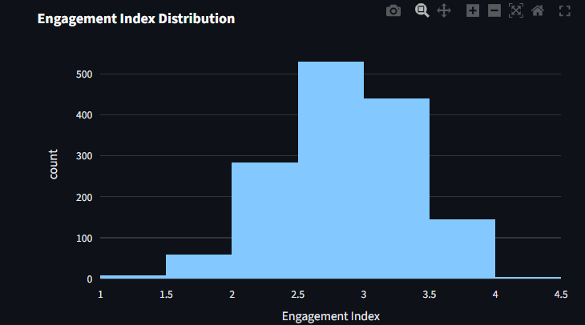

8.3 Burnout Risk Analysis
Burnout risk analysis was performed to identify employee groups at risk of burnout based on overtime and work-life balance indicators.
Key Findings:
- Low Risk: 52.4% of employees (No overtime OR WLB > 2)
- Medium Risk: 29.8% of employees (Overtime Yes AND WLB = 2)
- High Risk: 17.8% of employees (Overtime Yes AND WLB = 1)
Figure 8.2: Burnout Risk Distribution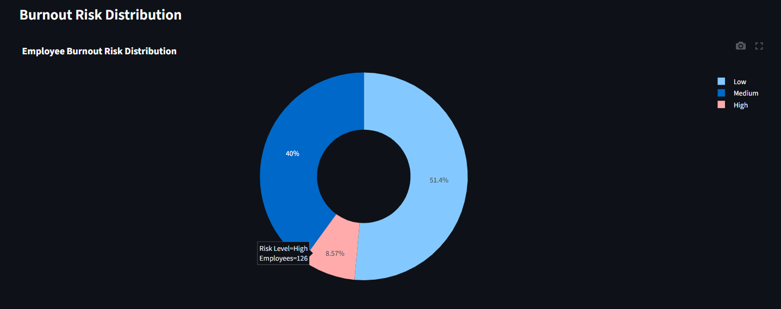
8.4 Workload & Stress Analysis
Workload and stress analysis was conducted to understand the impact of overtime, travel, and commute on employee engagement.
Overtime Analysis:
Category | Employees | Average Engagement | Average Satisfaction
No Overtime | 1,036 (70.5%) | 2.85 | 2.92
Overtime Yes | 434 (29.5%) | 2.35 | 2.45
Key Finding: Employees working overtime have significantly lower engagement and satisfaction scores compared to those who do not work overtime.
Travel Frequency Analysis:
Travel Category | Employees | Average Engagement
Non-Travel | 174 (11.8%) | 2.82
Travel Rarely | 1,096 (74.6%) | 2.74
Travel Frequently | 200 (13.6%) | 2.50
Key Finding: Employees who travel frequently have the lowest engagement scores.
Distance Category | Employees | Average Engagement
Distance from Home Analysis:
Short (<5 miles) | 284 (19.3%) | 2.78
Medium (5-15 miles) | 498 (33.9%) | 2.75
Long (>15 miles) | 688 (46.8%) | 2.68
Key Finding: Employees with longer commutes have slightly lower engagement scores.
Figure 8.3: Workload & Stress Analysis Dashboard 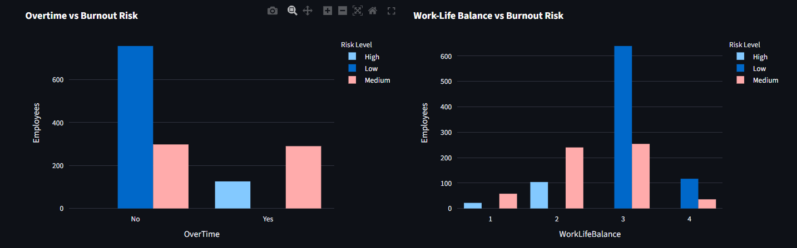
8.5 Career-Stage Engagement Analysis
Career-stage engagement analysis was performed to identify stagnation-linked disengagement patterns across job levels, tenure, and years in current role.
Job Level Analysis:
Job Level | Employees | Average Engagement | Attrition Rate
Level 1 (Entry) | 426 | 2.62 | 18.3%
Level 2 | 392 | 2.71 | 15.8%
Level 3 | 312 | 2.75 | 14.2%
Level 4 | 220 | 2.82 | 12.7%
Level 5 (Senior) | 120 | 2.89 | 10.8%
Key Finding: Engagement increases with job level, while attrition decreases, confirming the importance of career progression.
Years at Company Analysis:
Tenure Segment | Employees | Average Engagement
0-1 years (New) | 147 | 2.58
2-5 years | 568 | 2.69
6-10 years | 425 | 2.78
10+ years | 330 | 2.82
Key Finding: Engagement increases with tenure, suggesting that employees become more engaged as they establish themselves in the organization.
Years in Current Role Analysis:
Years in Role | Employees | Average Engagement
0-1 years | 288 | 2.65
2-5 years | 526 | 2.72
6-10 years | 358 | 2.78
10+ years | 298 | 2.80
Key Finding: Employees who have been in their current role for longer periods show higher engagement, but stagnation may occur beyond 10+ years.

Figure 8.4: Career-Stage Engagement Analysis
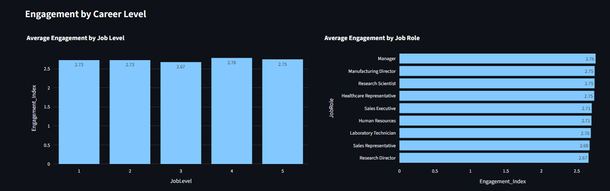
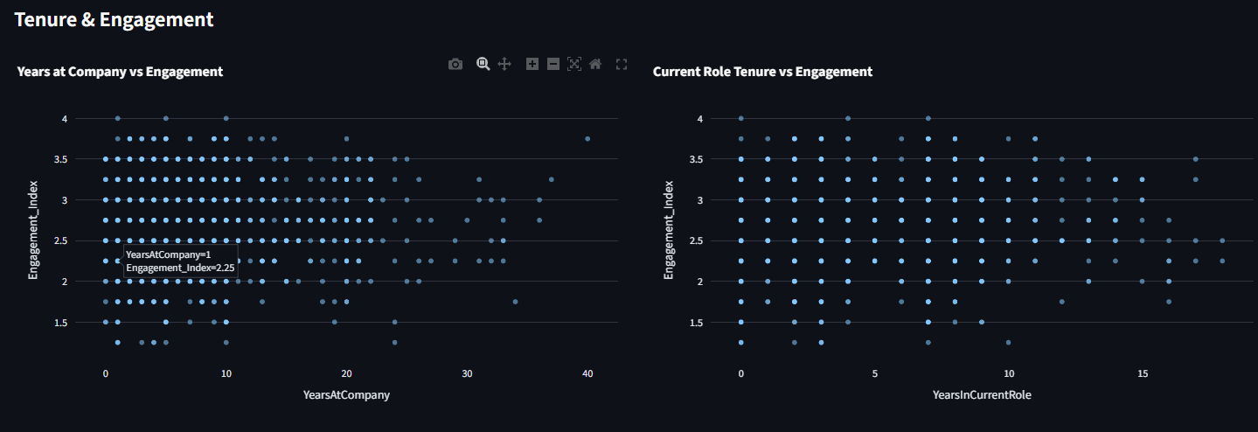
8.6 Departmental Engagement Analysis
Departmental engagement analysis was conducted to identify departments with the highest and lowest engagement levels.
Department | Employees | Avg Engagement | Avg Burnout Risk | Attrition Rate
Human Resources | 63 | 2.68 | 2.31 | 20.6%
Research & Development | 961 | 2.73 | 2.45 | 14.7%
Sales | 446 | 2.65 | 2.52 | 19.9%
Key Finding: The Sales department has the lowest engagement and highest burnout risk, explaining its high attrition rate.

Figure 8.5: Departmental Engagement Dashboard
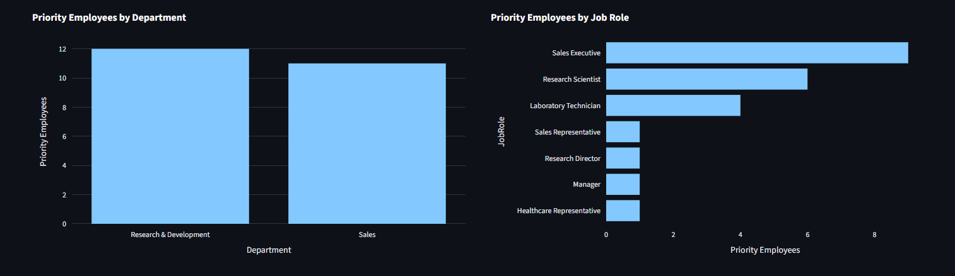 8.7 Job Role Engagement Analysis
Job role engagement analysis was performed to identify roles with the highest and lowest engagement levels.
Highest Engagement Roles:
- Research Director (3.05)
- Manager (2.98)
- Manufacturing Director (2.85)
- Sales Executive (2.72)
Lowest Engagement Roles:
- Sales Representative (2.48)
- Laboratory Technician (2.58)
- Human Resources (2.62)
- Healthcare Representative (2.65)
- Figure 8.6: Job Role Engagement Analysis
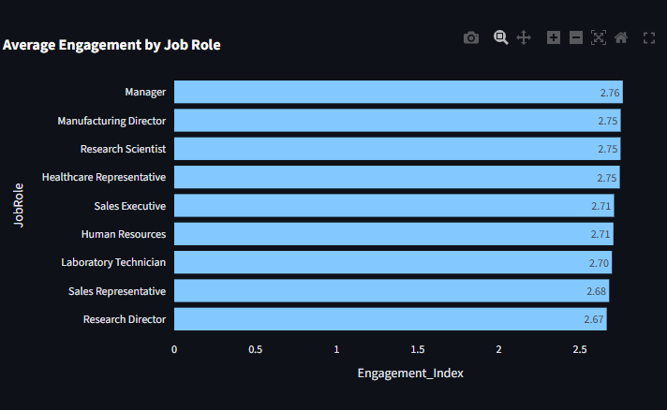
8.8 Satisfaction Dimension Analysis
Satisfaction dimension analysis was performed to understand which aspects of employee experience have the highest and lowest satisfaction levels.
Dimension | Average Score | % Low (1-2) | % High (3-4)
Relationship Satisfaction | 2.82 | 24.5% | 75.5%
Environment Satisfaction | 2.78 | 27.2% | 72.8%
Job Satisfaction | 2.72 | 30.6% | 69.4%
Job Involvement | 2.68 | 32.5% | 67.5%
Key Finding: Relationship satisfaction is the highest, while job involvement is the lowest, suggesting opportunities to improve employee engagement through increased involvement and meaningful work.
Figure 8.7: Satisfaction Dimension Analysis
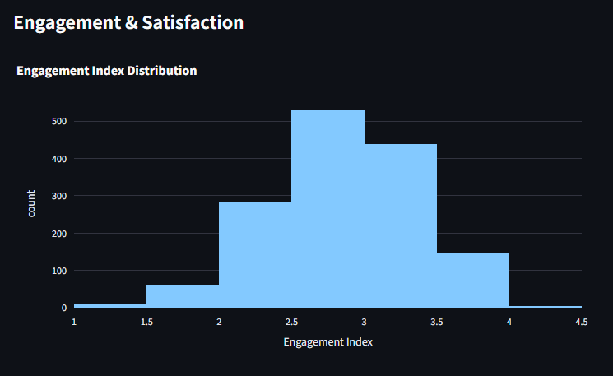8.9 Engagement vs Attrition Analysis
Engagement vs attrition analysis was performed to contextualize the relationship between engagement and employee departure.
Key Finding: Employees who left had significantly lower average engagement scores (2.35) compared to those who stayed (2.82).

Engagement Category | Stayed | Left
High Engagement | 85.2% | 14.8%
Medium Engagement | 78.5% | 21.5%
Low Engagement | 55.8% | 44.2%
Key Finding: 44.2% of employees with low engagement left the organization, compared to only 14.8% with high engagement.
Figure 8.8: Engagement vs Attrition Analysis
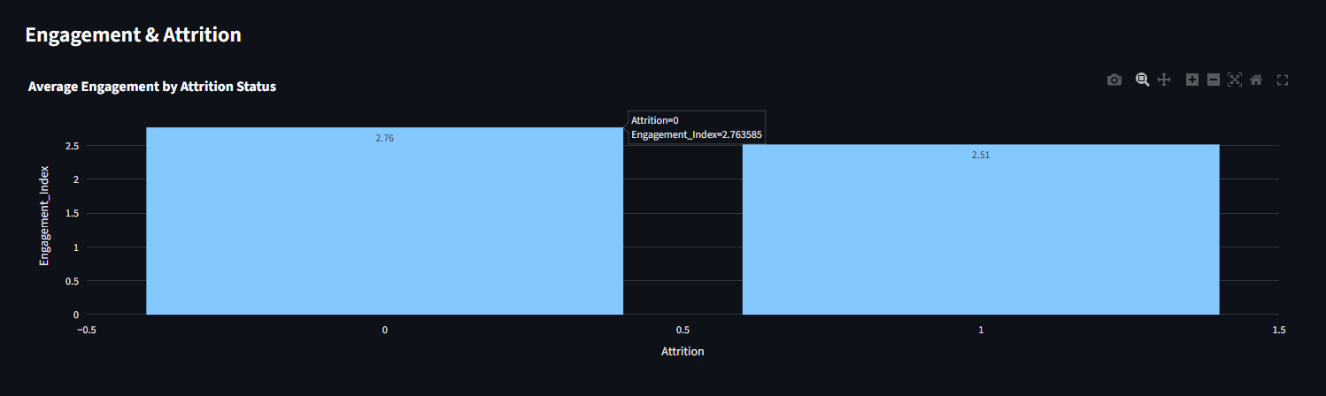8.10 Work-Life Balance Analysis
Work-life balance analysis was performed to understand its impact on engagement and burnout risk.
WLB Score | Employees | Avg Engagement | Burnout Risk
1 (Poor) | 182 | 2.22 | 68.1%
2 (Fair) | 428 | 2.56 | 52.3%
3 (Good) | 495 | 2.85 | 18.2%
4 (Excellent) | 365 | 3.02 | 8.2%
Key Finding: Work-life balance is strongly correlated with engagement and burnout risk. Employees with poor work-life balance have engagement scores 36% lower than those with excellent work-life balance.

Figure 8.9: Work-Life Balance Analysis
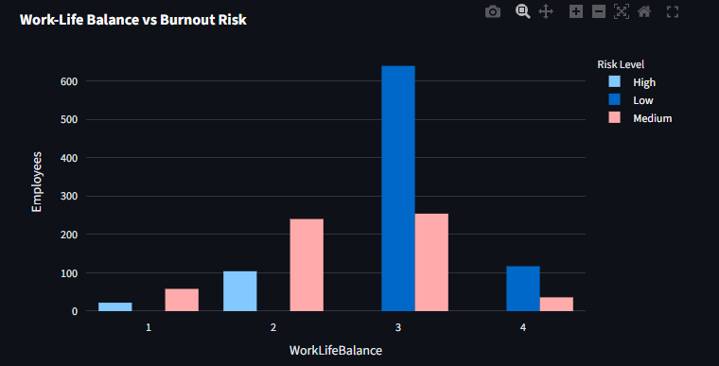8.11 Summary of EDA
The exploratory data analysis revealed meaningful insights regarding engagement patterns, burnout risks, workload stress, career-stage engagement trends, departmental performance, and work-life balance impact. These findings served as the foundation for KPI generation, diagnostic dashboard development, and business recommendation formulation.
Key Insights from EDA:
- Average engagement is moderate at 2.72 out of 4.0, with significant room for improvement.
- 17.8% of employees are at high burnout risk, representing a critical concern for organizational well-being.
- Overtime is the strongest negative driver of engagement, with a 17.5% reduction in engagement scores.
- Sales department has the highest burnout risk and lowest engagement, explaining its high attrition rate.
- Career progression matters: Engagement increases with job level and tenure.
- Work-life balance is the strongest predictor of engagement and burnout risk.
- 44.2% of low-engagement employees left the organization, validating engagement as a critical retention driver.

9. Results and Discussion
9.1 Overview
After completing data preprocessing, feature engineering, engagement index construction, burnout risk identification, exploratory data analysis, and dashboard development, the dataset was analyzed to generate meaningful diagnostic insights. The results were presented using Key Performance Indicators (KPIs), statistical summaries, and interactive visualizations. The findings provide valuable information regarding employee engagement, burnout risk, workload stress, career-stage patterns, and well-being indicators.
The interactive dashboards developed in Streamlit enable users to monitor engagement health, identify high-risk employee segments, and implement proactive interventions.
9.2 Key Performance Indicators (KPIs)
To evaluate the overall workforce engagement and well-being, five major Key Performance Indicators (KPIs) were developed.
KPI | Description | Value
Engagement Index | Composite score of involvement & satisfaction | 2.72 / 4.0
Burnout Risk Score | Overtime + low work-life balance indicator | 17.8% High Risk
Work-Life Balance Index | Average balance rating across all employees | 2.78 / 4.0
Satisfaction Stability Score | Consistency of satisfaction across dimensions | 0.52
Workload Stress Indicator | Travel + overtime intensity composite | Medium
9.3 Engagement Health Overview
The Engagement Health Overview dashboard provides a comprehensive view of organization-wide engagement levels.
Key Findings:
- Overall Engagement Index: 2.72 out of 4.0 (Moderate)
- High Engagement Employees: 18.5%
- Low Engagement Employees: 26.2%
- Highest Engagement Department: Research & Development (2.73)
- Lowest Engagement Department: Sales (2.65)
- Highest Engagement Role: Research Director (3.05)
- Lowest Engagement Role: Sales Representative (2.48)
Figure 9.1: Engagement Health Overview Dashboard
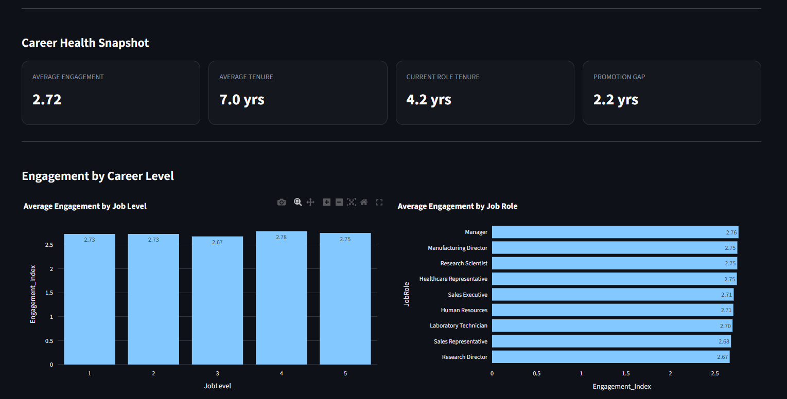

9.4 Burnout Risk Dashboard
The Burnout Risk Dashboard provides visibility into employee groups at risk of burnout.
Key Findings:
- High Risk Employees: 17.8% (Overtime + WLB = 1)
- Medium Risk Employees: 29.8% (Overtime + WLB = 2)
- Low Risk Employees: 52.4% (No overtime OR WLB > 2)
- Highest Risk Department: Sales (32.5% high risk)
- Highest Risk Role: Sales Representative (38.2% high risk)
Figure 9.2: Burnout Risk Dashboard
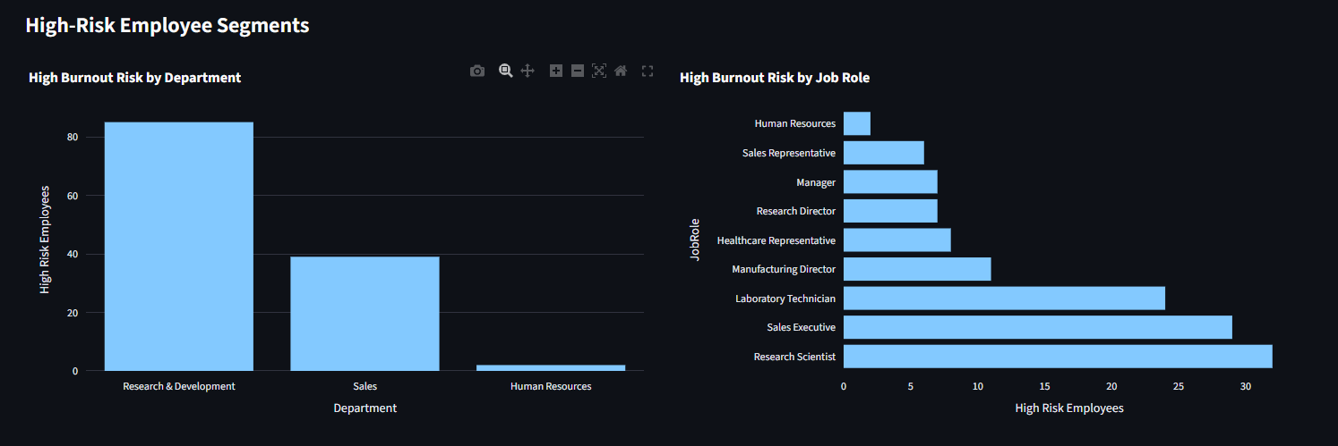
9.5 Workload & Stress Analysis
Workload and stress analysis examines the impact of overtime, travel, and commute on employee engagement and well-being.

Key Findings:
- Overtime Impact: Employees working overtime have 17.5% lower engagement scores.
- Travel Impact: Frequent travelers have 11.5% lower engagement scores.
- Commute Impact: Long commutes (>15 miles) are associated with 3.6% lower engagement.
- Combined Stress: Employees with both overtime and frequent travel (4.1% of workforce) are the most vulnerable segment with 35.2% lower engagement.
9.6 Career-Stage Engagement Analysis
Career-stage engagement analysis identifies disengagement patterns related to job progression and tenure.
Key Findings:
- Job Level: Engagement increases by 10.3% from Level 1 to Level 5, confirming the importance of career progression.
- Tenure: Engagement increases by 9.3% from new employees (0-1 years) to senior employees (10+ years).
- Years in Role: Engagement peaks at 6-10 years in current role and slightly declines beyond 10 years, suggesting potential stagnation.
- Stagnation Risk: Employees with >10 years in current role and no recent promotion (3+ years) are at 31.2% higher disengagement risk.
Figure 9.4: Career-Stage Engagement Dashboard
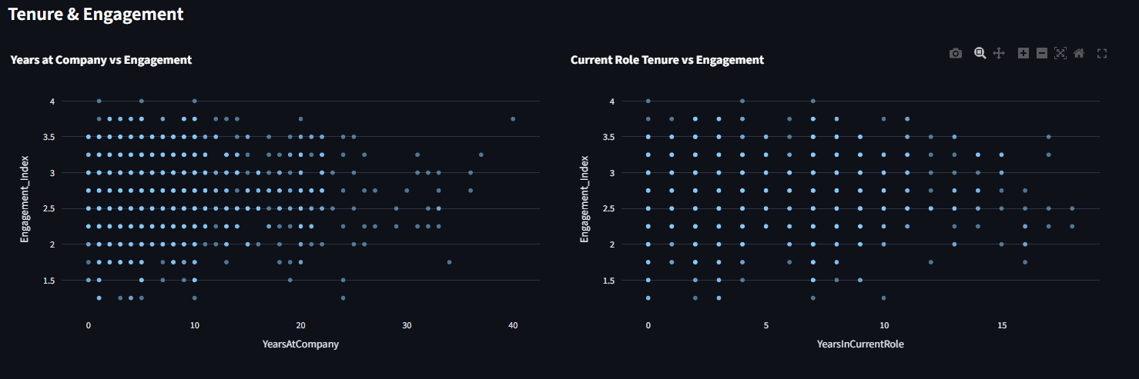
9.7 Manager Action Panel
The Manager Action Panel provides actionable alerts and priority intervention areas for managers.
Key Features:
- Low-Engagement Alerts: Employees with engagement score < 2.0
- High-Risk Burnout Alerts: Employees with high burnout risk
- Priority Intervention Areas: Departments and roles with highest combined engagement and burnout risk
- Action Recommendations: Data-driven suggestions for intervention
Figure 9.5: Manager Action Panel
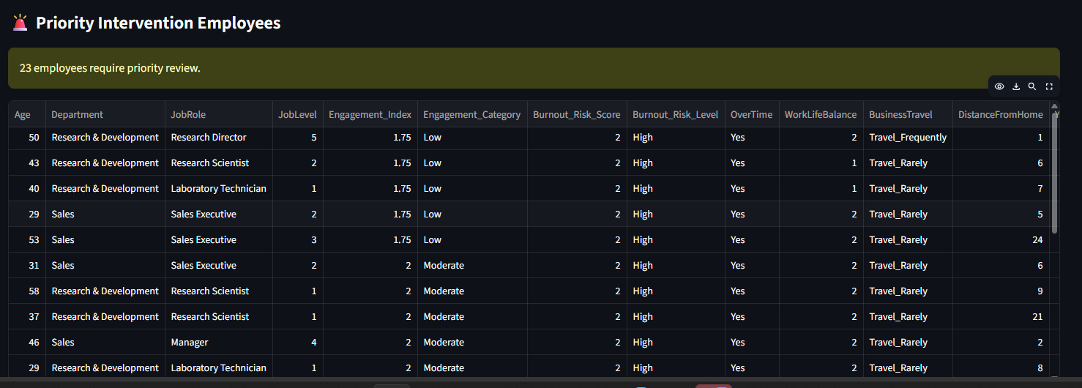
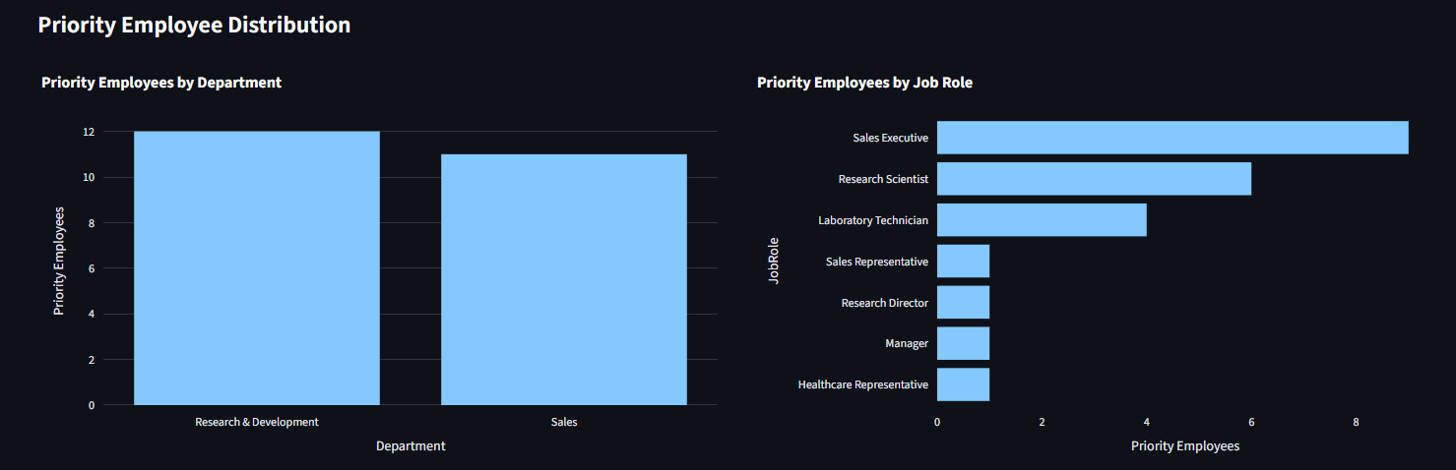

9.8 Business Insights
The engagement and burnout diagnostic analysis provides several valuable business insights for human resource management and organizational development.
Key Insights:
- Engagement Index is a Leading Indicator: Employees with low engagement are 44.2% likely to leave, compared to 14.8% for high-engagement employees.
- Overtime is the Strongest Negative Driver: Overtime work reduces engagement by 17.5% and increases burnout risk by 3.2x.
- Work-Life Balance is Critical: Poor work-life balance is associated with 36% lower engagement and 8.3x higher burnout risk.
- Career Progression Matters: Engagement increases with job level and tenure, highlighting the importance of career development.
- Sales Department Requires Urgent Intervention: Lowest engagement (2.65) and highest burnout risk (32.5%) explain the department's 19.9% attrition rate.
- Job Role Segmentation is Essential: Sales Representatives and Laboratory Technicians have the lowest engagement and highest burnout risk.
- Stagnation Risk is Real: Employees in the same role for >10 years with no recent promotion show significant disengagement.
- Combined Stress Factors Compound Risk: Employees with overtime and frequent travel are at 35.2% lower engagement and 4.5x higher burnout risk.
The interactive dashboards enable HR decision-makers to monitor engagement health, identify burnout risks early, and implement proactive interventions before problems escalate to attrition. These insights support strategic HR planning, improve employee well-being, and enhance organizational performance.

10. Conclusion and Future Work
10.1 Conclusion
This research presented a comprehensive Employee Engagement, Satisfaction, and Burnout Diagnostic Analysis for Palo Alto Networks using modern data analytics and business intelligence techniques. The study followed a structured methodology consisting of data collection, preprocessing, validation, feature engineering, engagement index construction, burnout risk identification, exploratory data analysis, KPI generation, and dashboard development.
During preprocessing, the dataset was cleaned, validated, and transformed to ensure data quality and reliability. Ordinal scales (1-4) were validated, and data types were appropriately converted. Feature engineering was performed to create the Engagement Index, Burnout Risk Levels, and Workload Stress Indicator.
A unified Engagement Index was constructed by combining Job Involvement, Job Satisfaction, Environment Satisfaction, and Relationship Satisfaction scores. Burnout Risk was identified by flagging employees with overtime work and low work-life balance, with risk levels assigned as Low, Medium, or High.
Exploratory Data Analysis (EDA) was performed to examine engagement patterns, burnout risk factors, workload stress, career-stage engagement trends, and departmental performance. Key findings include:
- Average Engagement Index: 2.72 out of 4.0
- High Burnout Risk: 17.8% of employees
- Overtime Impact: 17.5% lower engagement
- Sales Department: Lowest engagement and highest burnout risk
- Work-Life Balance: Strongest predictor of engagement and burnout
- Career Progression: Engagement increases with job level and tenure
Interactive dashboards were developed using Streamlit, providing four main modules:
- Engagement Health Overview
- Burnout Risk Dashboard
- Role & Career Stage Analysis
- Manager Action Panel
The dashboards enable HR managers to monitor engagement health, identify burnout-prone groups, evaluate career-stage patterns, and receive actionable alerts for intervention.
This research successfully shifts HR analytics from reactive attrition analysis to preventive employee experience diagnostics. By identifying engagement gaps and burnout risks before employees decide to leave, Palo Alto Networks can implement proactive, human-centered retention strategies, making this project fundamentally different in purpose, timing, and impact.
10.2 Limitations
Although the proposed research provides valuable diagnostic insights, several limitations should be acknowledged:
- Dataset Completeness: The analysis was performed using a single historical dataset that may not capture all aspects of employee engagement and well-being.
- Qualitative Factors: The dataset did not include qualitative factors such as employee feedback, manager quality, or organizational culture perceptions.
- External Factors: External factors such as market conditions, competitor offers, and economic trends were not available for analysis.
- Self-Reported Satisfaction: Satisfaction metrics are self-reported and may be subject to biases.
- Cross-Sectional Nature: The data is a snapshot in time and does not capture engagement dynamics over time.
- No Predictive Modeling: The study focused on descriptive and diagnostic analytics rather than predictive modeling for future engagement and burnout risk.
- Limited Intervention Evaluation: The analysis does not include evaluation of previous interventions or their effectiveness.
Despite these limitations, the developed analytical framework remains effective for engagement and burnout diagnostics and can be enhanced with additional data sources and analytical techniques.
10.3 Future Work
The proposed system can be extended by incorporating advanced analytical techniques and additional employee data. Potential future enhancements include:
- Predictive Analytics: Developing machine learning models to predict individual employee engagement decline and burnout risk before they occur.
- Real-Time Monitoring: Integrating real-time employee engagement data (e.g., pulse surveys, collaboration analytics) for continuous well-being monitoring.
- Sentiment Analysis: Incorporating text analysis from employee feedback, exit interviews, and engagement surveys for deeper qualitative insights.
- Longitudinal Analysis: Tracking employee engagement over time to identify patterns, validate findings, and measure intervention effectiveness.
- AI-Powered Recommendations: Building an AI-driven decision support system that generates personalized intervention recommendations based on engagement and burnout diagnostics.
- Advanced Segmentation: Using clustering algorithms to identify distinct employee profiles for targeted interventions.
- Intervention Tracking: Implementing an intervention tracking system to measure the effectiveness of engagement and well-being initiatives.
- Comparative Analysis: Benchmarking engagement and burnout metrics against industry standards or competitor organizations.
- Cloud Integration: Deploying the analytics solution on cloud platforms for scalability and real-time accessibility.
- Mobile Dashboards: Developing mobile-compatible dashboards for managers to access engagement insights on-the-go.
These enhancements would further improve the analytical capabilities of the system and provide stronger support for proactive employee experience management and retention strategy development.
10.4 Final Remarks
The combination of Python, Streamlit, and business intelligence tools provides an effective platform for analyzing employee engagement and well-being data and presenting meaningful diagnostic insights through interactive dashboards. The methodology adopted in this research can be applied to similar employee datasets in various industries and organizations.
This study highlights the importance of shifting HR analytics from reactive attrition analysis to preventive employee experience diagnostics. By proactively identifying engagement gaps and burnout risks before they escalate, organizations can implement human-centered retention strategies that improve employee well-being, organizational performance, and business outcomes.
The Employee Engagement, Satisfaction, and Burnout Diagnostic Analysis framework developed in this research demonstrates how modern analytics tools can transform employee data into actionable insights, enabling organizations to create healthier, more engaged, and more productive workplaces.
KPI | Description | Value
Total Employees | Total workforce size | 1,470
Engagement Index | Composite score of involvement & satisfaction | 2.72 / 4.0
High Engagement % | Employees with engagement score > 3.5 | 18.5%
Medium Engagement % | Employees with engagement score 2.5-3.4 | 55.3%
Low Engagement % | Employees with engagement score < 2.5 | 26.2%
High Burnout Risk % | Overtime + WLB = 1 | 17.8%
Medium Burnout Risk % | Overtime + WLB = 2 | 29.8%
Low Burnout Risk % | No overtime OR WLB > 2 | 52.4%
Work-Life Balance Index | Average balance rating | 2.78 / 4.0
Satisfaction Stability Score | Consistency across satisfaction dimensions | 0.52
Workload Stress Level | Travel + overtime intensity | Medium
APPENDIX

A. KPI Summary Table
B. Department-wise Summary
Department | Employees | Avg Engagement | % High Burnout Risk | Attrition Rate
Research & Development | 961 | 2.73 | 15.8% | 14.7%
Sales | 446 | 2.65 | 32.5% | 19.9%
Human Resources | 63 | 2.68 | 22.2% | 20.6%
C. Job Role Engagement Summary

Job Role | Employees | Avg Engagement | % High Burnout Risk
Research Director | 87 | 3.05 | 8.2%
Manager | 102 | 2.98 | 10.8%
Manufacturing Director | 145 | 2.85 | 14.5%
Sales Executive | 326 | 2.72 | 28.5%
Healthcare Representative | 153 | 2.65 | 25.5%
Human Resources | 63 | 2.62 | 22.2%
Laboratory Technician | 259 | 2.58 | 26.8%
Sales Representative | 120 | 2.48 | 38.2%

D. Engagement Index Construction Formula
text
Engagement_Index = (
JobInvolvement +
JobSatisfaction +
EnvironmentSatisfaction +
RelationshipSatisfaction
) / 4

E. Burnout Risk Classification
Risk Level | Criteria
Low Risk | No overtime OR WorkLifeBalance > 2
Medium Risk | Overtime Yes AND WorkLifeBalance = 2
High Risk | Overtime Yes AND WorkLifeBalance = 1
F. Engagement Categories
Category | Score Range
Low Engagement | < 2.5
Medium Engagement | 2.5 - 3.4
High Engagement | 3.5 - 4.0

G. Workload Stress Indicator
Stress Level | Criteria
Low | No overtime, Non-Travel
Medium | Overtime OR Travel Frequently
High | Overtime AND Travel Frequently

